# **Chapter 3: Programming Fundamentals**

**All Lectures Uploaded on YouTube:**

[**https://tinyurl.com/fkm9-cs**](https://tinyurl.com/fkm9-cs)

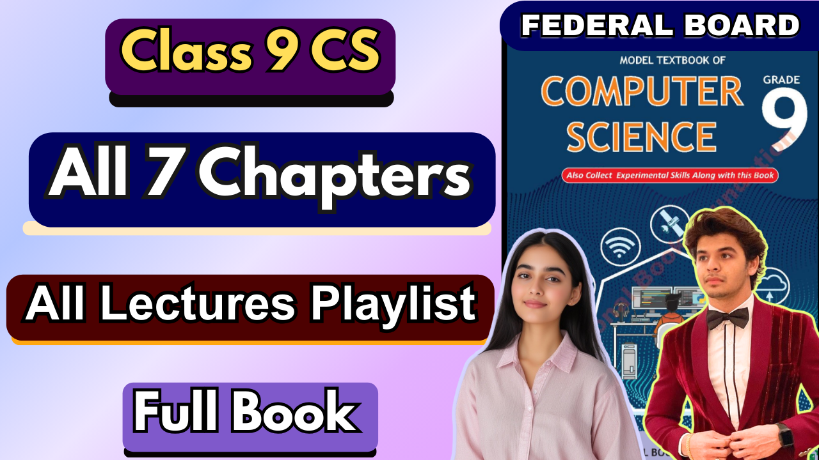

**3.1 Introduction**

Programming Fundamentals refers to the basic concepts, tools, and techniques used to create computer programs and websites. In modern computing, programming is not limited to writing code for computers only, but also for designing interactive websites and web applications. This chapter introduces students to web technologies such as HTML, CSS, and JavaScript, which together help in creating structured, styled, and interactive websites. Understanding programming fundamentals helps students develop logical thinking, problem-solving skills, and creativity.

**3.1.1 Web and the Website**

The World Wide Web (WWW) is a global system of interconnected documents and resources that are accessed through the internet. These documents are known as web pages and are viewed using a web browser such as Google Chrome or Mozilla Firefox.

A website is a collection of related web pages stored on a web server and identified by a unique address called a URL (Uniform Resource Locator). Websites may contain text, images, audio, video, and hyperlinks.

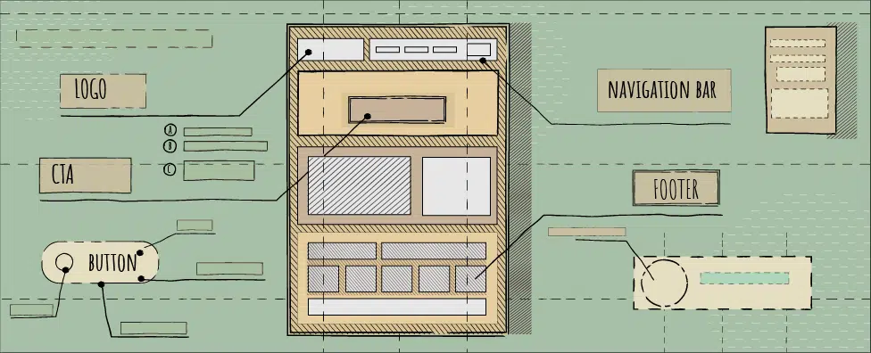

**3.1.2 Web Application**

A web application is an interactive software program that runs on a web server and is accessed through a web browser. Unlike simple websites, web applications allow users to enter data, process information, and receive customized results.

Examples include email services, online banking systems, learning management systems, and social media platforms.

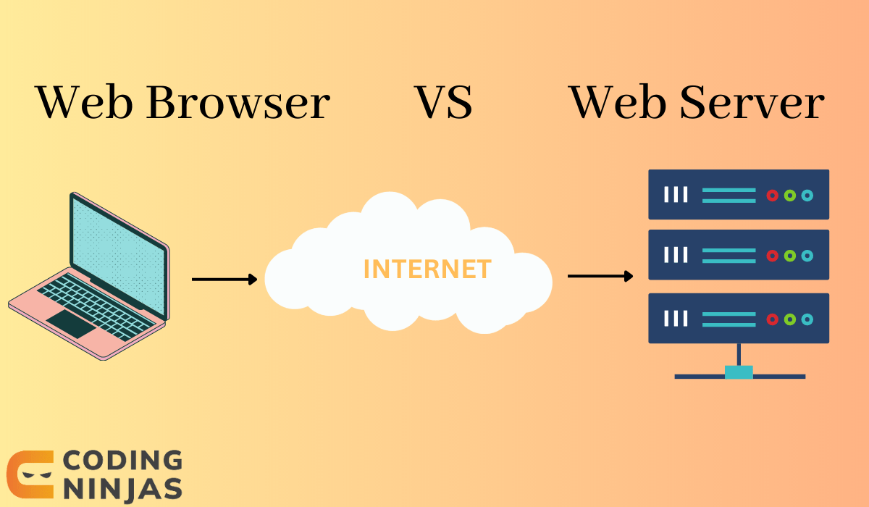

**3.1.3 Website Development**

Website development is the process of designing, creating, and maintaining websites. It involves writing code, designing layouts, adding multimedia, and ensuring proper functionality. Website development is broadly divided into front end development and back end development.

**3.1.4 Static Website**

A static website displays fixed content and does not change unless the developer manually updates the code. These websites are built using HTML and CSS only and do not use databases.

Advantages include simplicity, faster loading time, and low development cost.

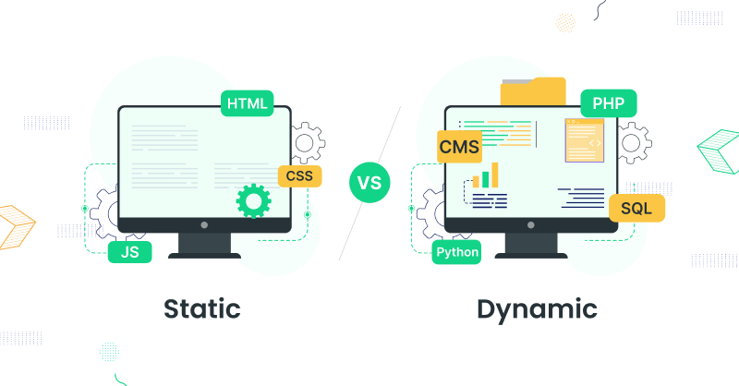

**3.1.5 Dynamic Website**

A dynamic website displays content that can change according to user interaction or database information. These websites use HTML, CSS, JavaScript, and server-side languages.

Examples include e-commerce websites, social media platforms, and online portals.

**3.1.6 Front End Development**

Front end development focuses on the visual appearance and user interaction of a website. It is the part of the website that users see and interact with.

Technologies used include HTML for structure, CSS for styling, and JavaScript for interactivity.

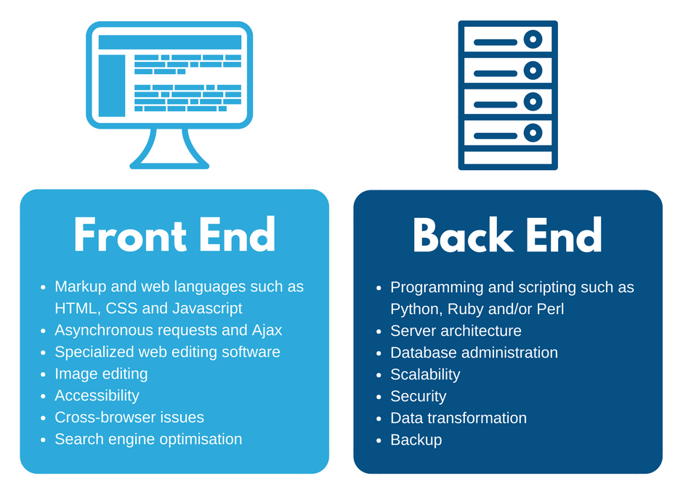

**3.1.7 Back End Development**

Back end development deals with the server-side operations of a website. It manages data storage, user authentication, and application logic.

Back end developers work with server-side languages and databases.

**3.2 HTML**

HTML (HyperText Markup Language) is the standard language used to create web pages. It uses tags to define the structure and layout of content on a webpage.

* Character(s) between angle brackets '<'and '>' are called tags.
* We have to define from where to start and end the effect of every component. Therefore, we place <p>, the starting marker, in the start of the sentence and </p>, the closing marker, after the sentence

There are many softwares/IDE environments available that help in minimizing your coding efforts. Visual Studio, Netbeans, etc.

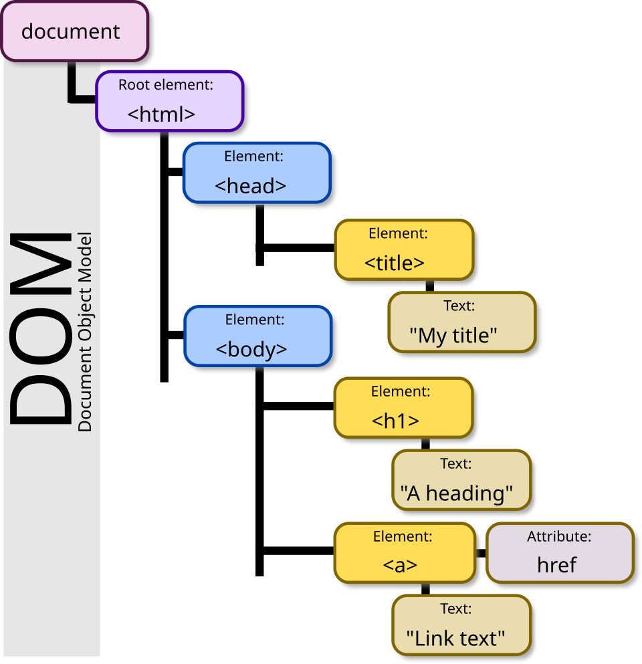

**3.2.1 HTML Document Object Model**

The HTML Document Object Model (DOM) is a tree-like structure that represents the elements of an HTML document. Each element is treated as an object, allowing programs like JavaScript to access and modify webpage content dynamically.

**3.2.2 Tags in HTML**

HTML tags are predefined keywords enclosed in angle brackets. Most tags come in pairs, consisting of an opening and a closing tag.

**3.2.2.1 HTML Tag**

The <html> tag is the root element of an HTML document. It contains all other elements of the webpage.

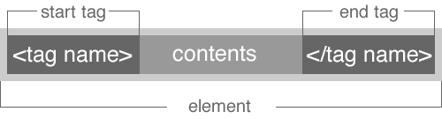

**3.2.2.2 Head Tag**

The <head> tag contains meta-information about the webpage such as title, character encoding, and links to stylesheets.

**3.2.2.3 Title Tag**

The <title> tag specifies the title of the webpage that appears on the browser tab.

**3.2.2.4 Body Tag**

The <body> tag contains all the visible content of the webpage including text, images, links, and multimedia.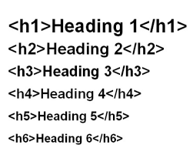

**3.2.2.5 Tags for Headings**

HTML provides six heading tags from <h1> to <h6>, used to define headings of different importance.

**3.2.2.6 Tag for Line Break**

The <br> tag is used to insert a line break in the text without starting a new paragraph.

**3.2.2.7 Tag the Text**

Text formatting tags are used to enhance text appearance. Examples include bold, italic, underline, and paragraph tags.

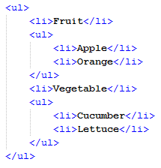

**3.2.2.8 Bullets & Numbering**

Lists are used to display items in bullet or numbered form. Unordered lists use <ul> and ordered lists use <ol>.

**3.2.3 Manipulating Data with Tables**

Tables are used to display data in rows and columns using table-related tags.

The first row of the table is the header row and is generally used for headings and is defined with the 'th' tag-pair. Whereas data is manipulated through 'td' tag-pair.

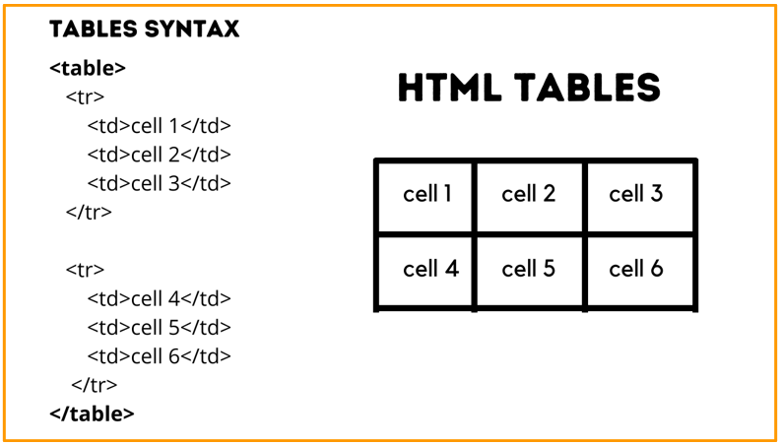

**3.2.4 Links to Resources**

Hyperlinks are created using the anchor tag to link web pages, documents, images, or external websites.

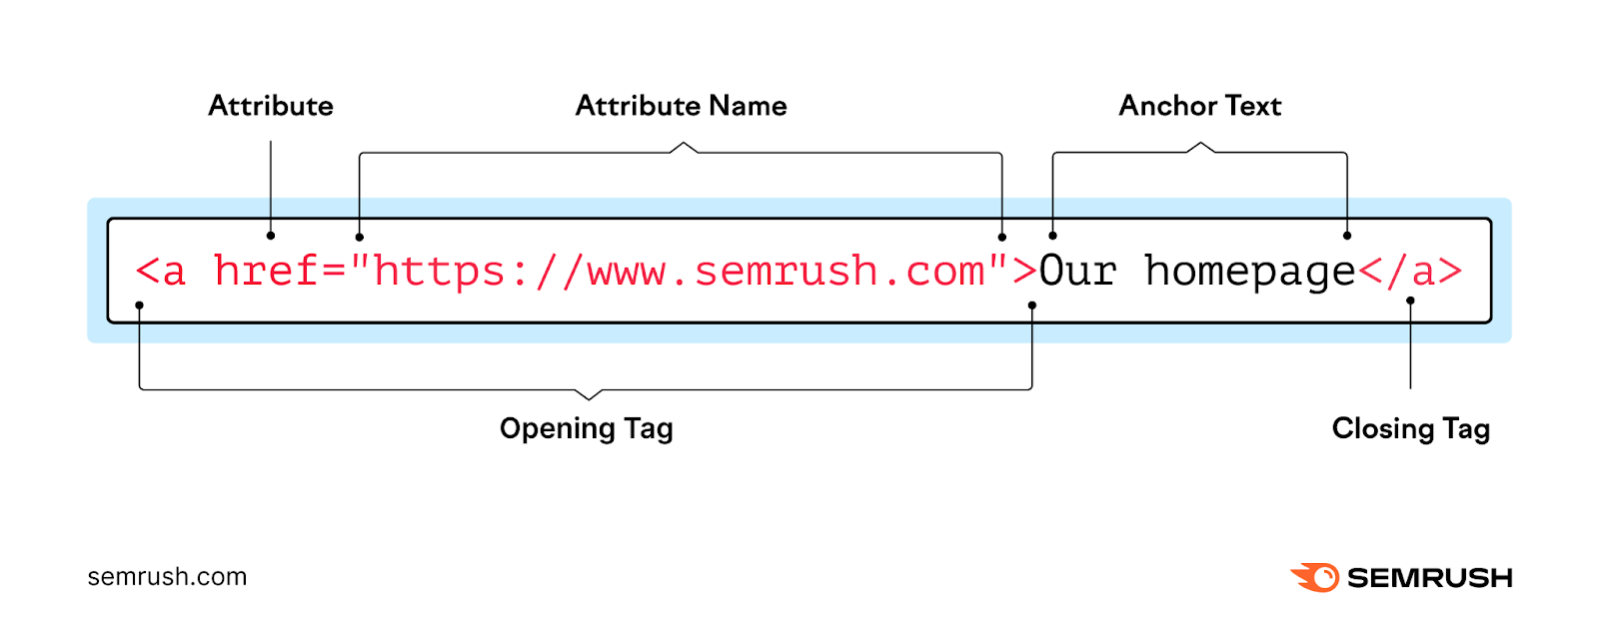

* The general syntax for defining a link is like "link text", where href refers to the address along with the path and link-text is for user information.
* Target is an optional parameter but its value defines where to open the webpage.
* If the value chosen is 'blank', it will open in a new tab or window; however for the value of 'self' the destination address will open in the same tab or window.

**3.3 Cascading Style Sheets (CSS)**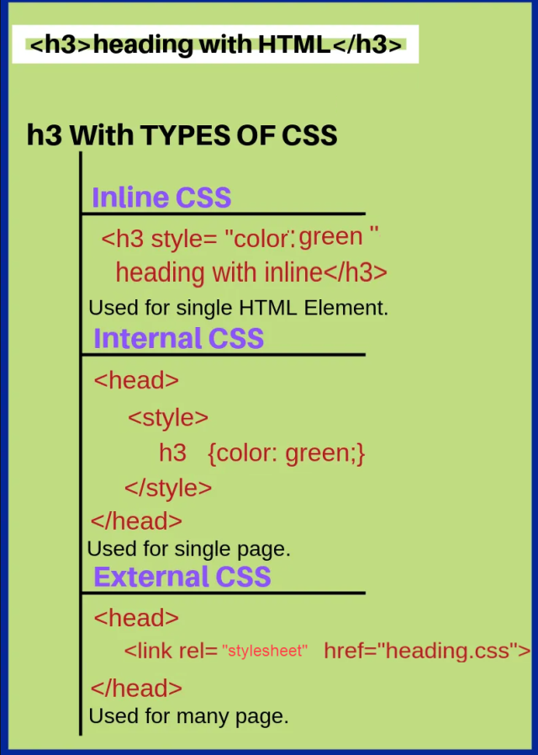

CSS is used to control the appearance and layout of web pages. The most common and frequently used with HTML is CSS. So, this way the contents of the webpage are defined through HTML while the look of different components is handled via CSS.

**Inline CSS:** Applied directly within an HTML element.

**Embedded CSS:** Written inside the <style> tag.

**External CSS:** Written in a separate file and linked to HTML.

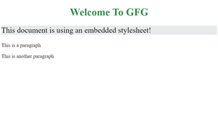

**3.3.1 Decorating Tables with CSS**

CSS can be used to add borders, colors, spacing, and alignment to tables.

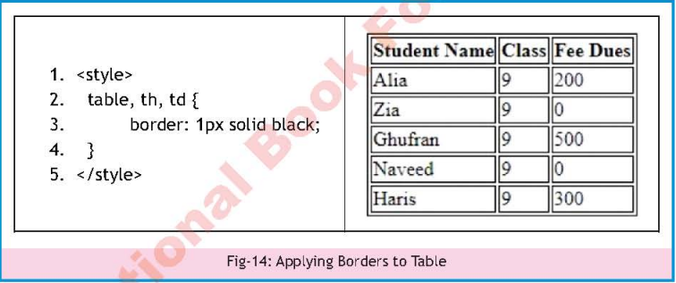

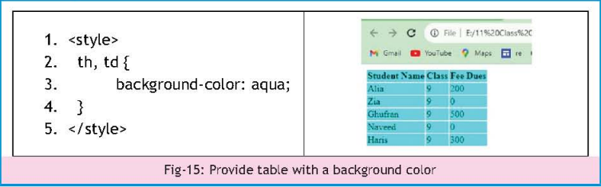

**3.3.2 Homepage Decor**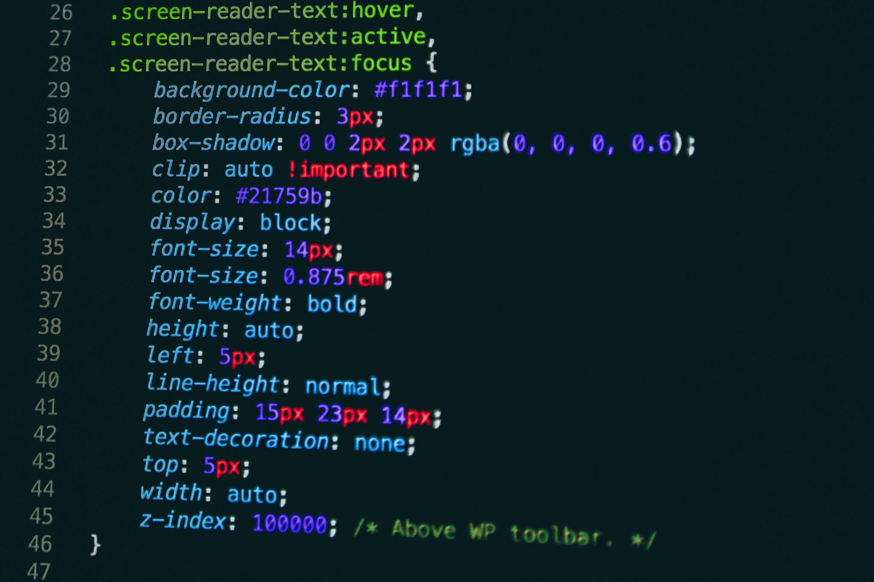

CSS enhances homepage design by controlling layout, fonts, colors, and background images.

**3.3.3 Adding a Video Clip in Website**

The <video> tag is used to embed video content in a webpage.

**3.4 JavaScript**

JavaScript is a scripting language used to make web pages interactive. It does not consume much memory and that is why it is used at the client end in developing websites, for making pages dynamic.

**3.4.1 Let’s Meet JavaScript**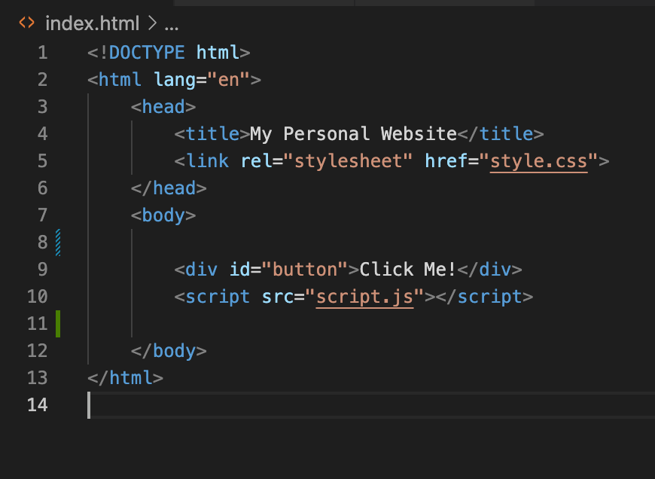

JavaScript code can be written within script tags or in external files.

In programming everything that a user or another program does with your program that can be sensed and triggers some task to be done, is called an 'event'. Events are important and critical in the functioning and flow-control of your program.

**3.4.2 Variables**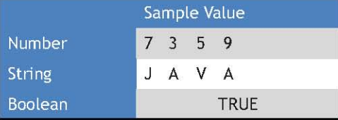

Variables store data values used in programs. In mathematics, a variable is generally represented by a single character, but not limited to. Similarly, in programming languages, variables should be named in a meaningful manner.

Avariable is declared with the 'var' keyword and multiple variables can be declared in the same line of code, too. The first ever assignment of a value to a variable in the life span of program is called 'initialization'.

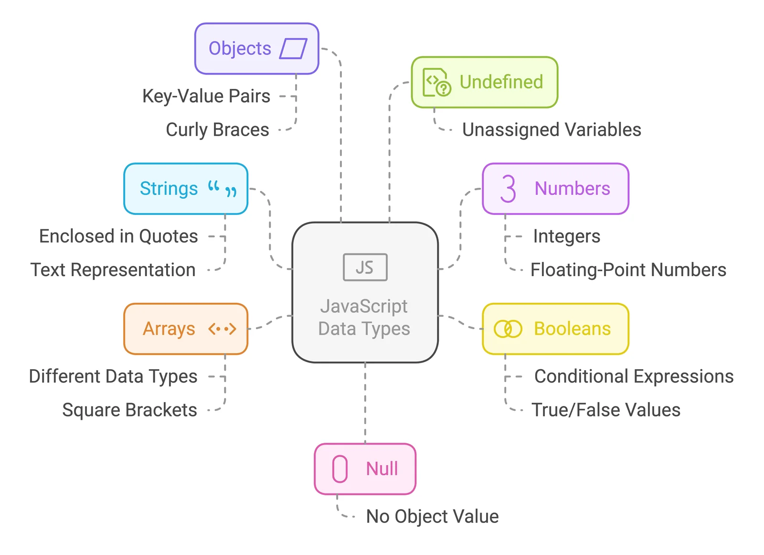

**3.4.3 Operators**

Operators perform mathematical and logical operations.

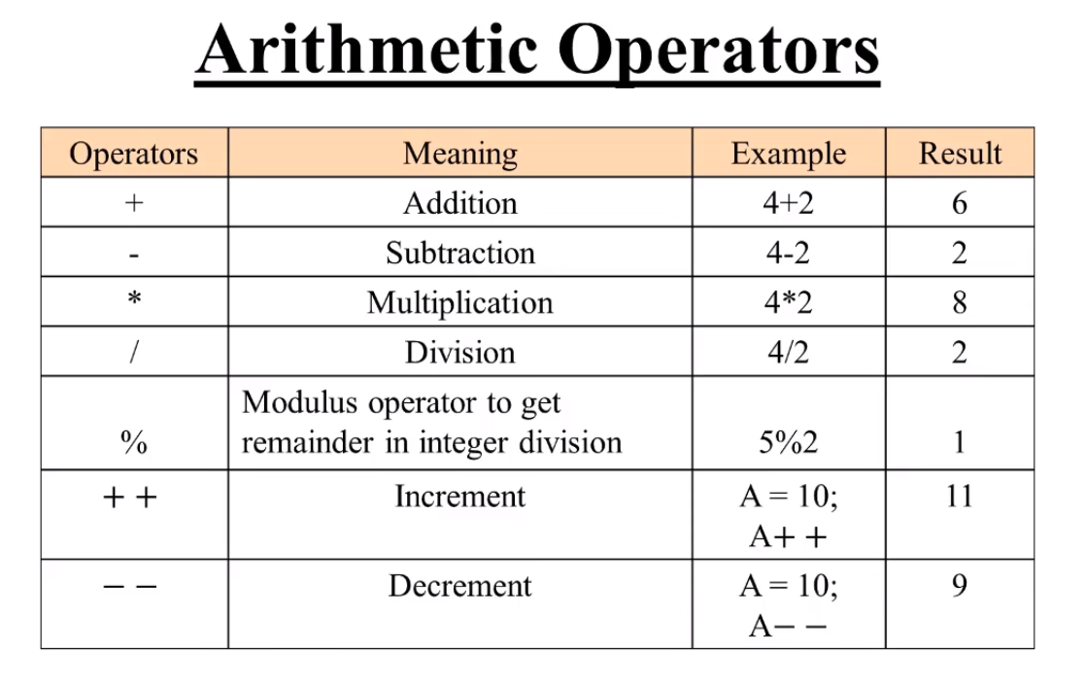

Javascript supports arithmetic operators to be used which are Addition (+), Subtraction (-), Multiplication (*) and Division (/). Other than this, the Modulus (%) operator can also be used which gives the remainder of a division operation.

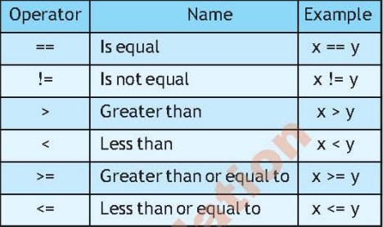

**3.4.4 Conditional Statement**

Conditional statements allow decision-making in programs. Conditional or selection statement is an essential part of the program where amongst choices, the program chooses on the basis of some constraint.

**3.4.5 Iterative Statement**

Iterative statements like 'For Loop' are used to get similar kinds of tasks done. Rather than writing the same line of code multiple times, the same task is achieved in much fewer lines of code.

* The 'for loop' works on the basis of an index, which you can initialize in the loop.
* Next is the terminating condition which needs to be set for the loop to terminate.
* Lastly, step-size needs to be defined that how many steps the index will take after each iteration; till the terminating condition is met.

In the following example 'for loop', an index is initialized to 0, the value of index will increment with 1 and loop will execute till index value remains less than the number of elements in ‘students’.

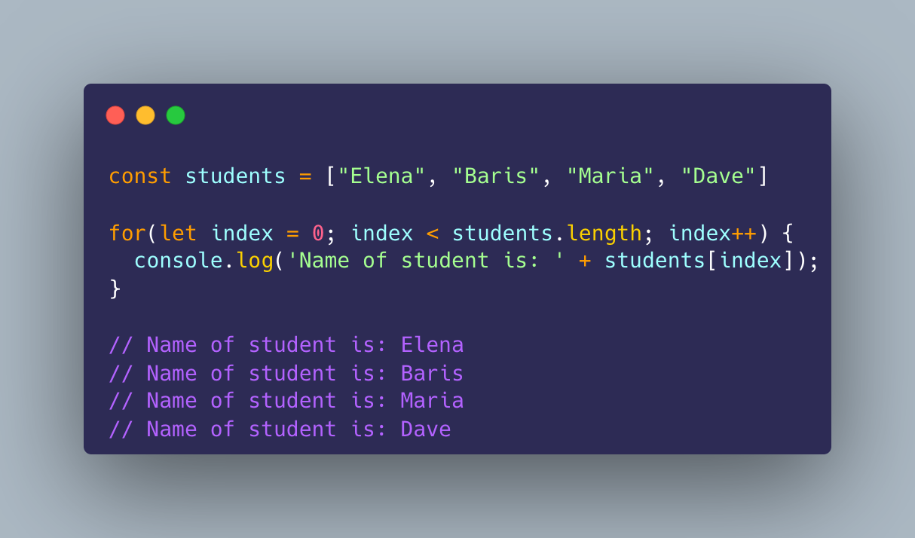

**3.4.6 Nested Loops**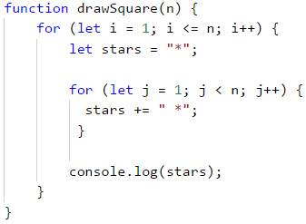

Nested loops are loops placed inside other loops.

In a nested loop, initially the outer loop will start and then the inner loop will run and finish. Thereafter, the index value of the outer loop will increment and the inner loop will start and end again, and so forth and so on; till the outer loop terminates.

**3.4.7 Arrays**

Arrays store multiple values in a single variable. It is a datatype which can hold a number of homogenous sets of elements. Such that we do not need to define multiple variables of the same type like num1, num2, ... num25. Instead, we can declare an array which contains 25 values.

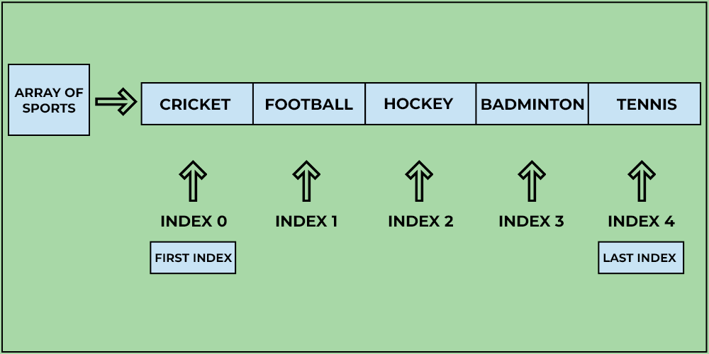

**3.4.8 Functions**

Functions are reusable blocks of code that perform specific tasks. It is a set of lines which occurs in the code quite often that can be segmented once, and called again and again. This way, rewriting the same set of code for similar results can be eliminated.

* A function has a name through which it is identified and called.
* It can have arguments which are variables local to that function and their life span limited to the said function.
* Variables outside functions are global variables and can be accessed anywhere from the program.

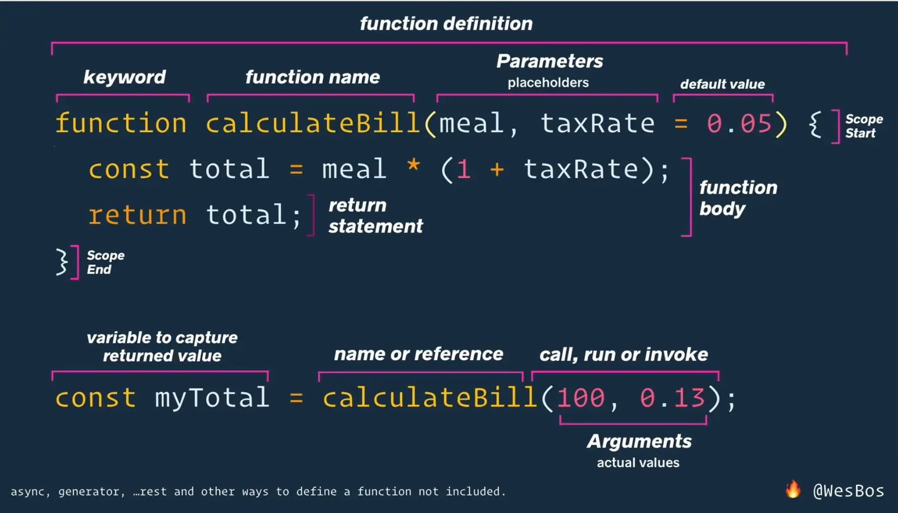

**3.5 Debug the Code**

Debugging is the process of finding and fixing errors in a program.

* In Visual Studio .Net, Select Run from the menu and choose 'Run Debugging'. 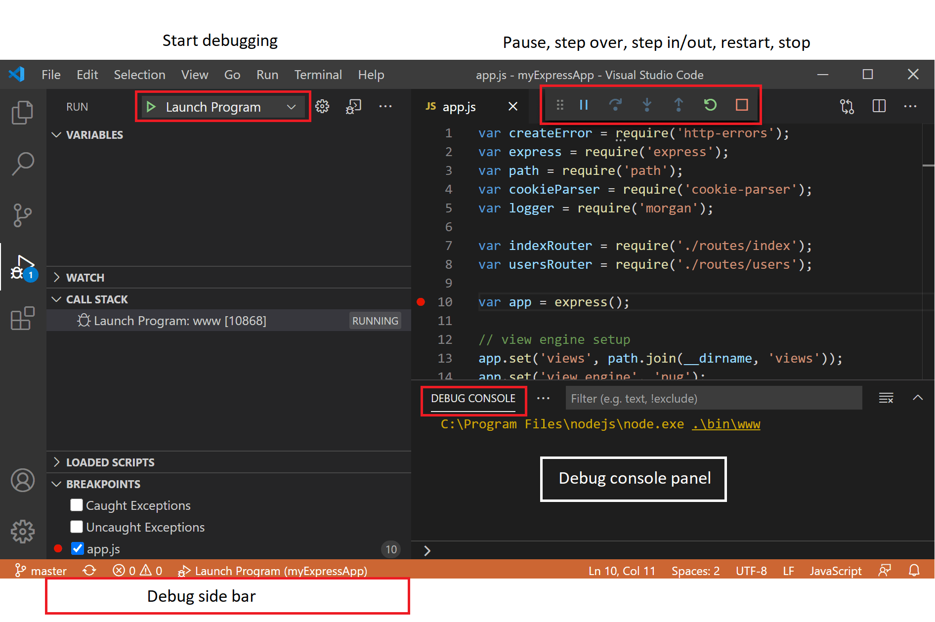
* Thereafter, you will get the Debugging menu with some buttons and a debug console.
* You can assign multiple breakpoints for the sake of traceability.
* In Visual Studio. Net, a breakpoint is shown as a red dot at the start of the line.

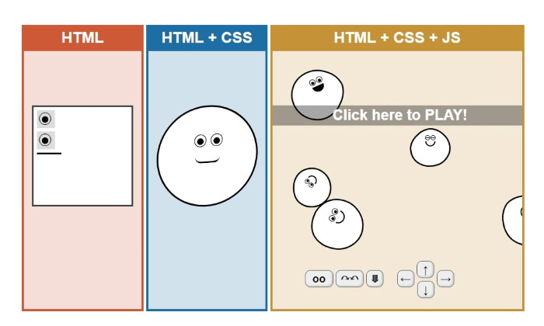

**3.6 Create a Dynamic Website**

A dynamic website combines HTML, CSS, JavaScript, and backend technologies to display interactive and data-driven content.

If a school wants to display the result of each student on their website, then they have to create a different static webpage for each student. And as the students increase, so does the handling and managing of these webpages. Such dynamic websites can be created via JavaScript along with HTML and CSS.





